Breadboard Consulting Pvt Ltd - Website design

Home (Page 1)
1. Hero
Strategic Advisory for CSR, Development and Institutional Impact
Designing structured systems that translate intent into measurable action.
Button:
Schedule a Consultation
Breadboard is a professional advisory and consulting firm working at the intersection of corporate responsibility, development programming, and institutional strengthening. We partner with corporates, development organizations, and public sector stakeholders to design high-impact programs, improve delivery systems, and support evidence-based decision-making.
Our work is focused on building scalable, implementation-ready solutions that balance strategic intent with on-ground realities. Breadboard brings together program design expertise, operational understanding, and analytical rigor to support organizations across the full project lifecycle.
What We Do (Condensed Grid)
CSR & Corporate Advisory
Structured, compliant CSR portfolios aligned with measurable outcomes.
Development & Impact Consulting
Scalable program design and performance systems.
Research & Advocacy Advisory
Evidence-led insight and institutional positioning.
Marketing & Digital Enablement
Strategic communication and structured digital presence.
Button:
View Services
Why Breadboard
The core gap where impact weakens lies in how institutions operate: strategy is designed in isolation, systems remain underbuilt, and execution is left to adjust in the field. The result is fragmentation and diluted outcomes. Our model works to close that gap.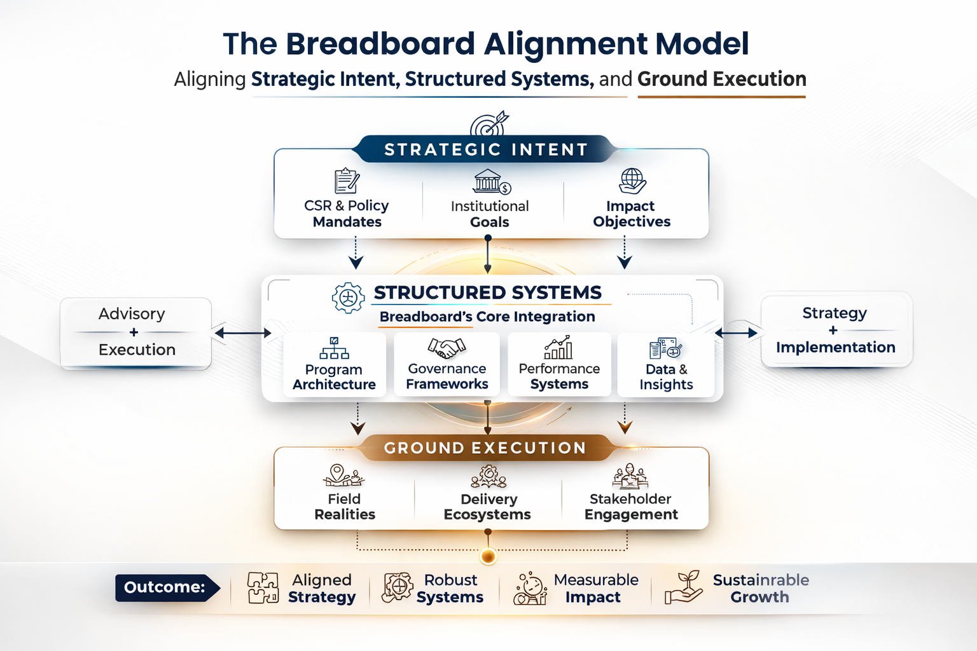
(Model Diagram)

About Us (Page 2)
Breadboard supports organizations in designing, implementing, and strengthening development and impact-focused programs across diverse thematic areas and institutional contexts. We work with clients to translate strategic objectives into structured program models, operational frameworks, and measurable outcomes.
Our work spans program advisory, institutional capacity building, impact measurement, research support, and strategic communication. By combining advisory expertise with execution-focused planning and data-driven evaluation, we help organizations improve performance, accountability, and long-term sustainability.
Our Approach
Breadboard Consulting follows a structured, outcome-driven approach to advisory and program support. We focus on building solutions that are strategically aligned, operationally feasible, and designed for long-term sustainability rather than short-term project success.
Our approach emphasizes continuity, institutional capacity, and system-level impact to ensure that programs remain effective beyond implementation timelines.
Need-Based Program Design
We begin by grounding our work in contextual assessment and real stakeholder needs. By prioritizing relevance, local realities, and institutional readiness, we design programs that are demand-driven, adaptable, and capable of sustaining impact over time.
Collaborative Ecosystem Building
We believe that long-term impact is created through collaboration, not isolated interventions. Our approach focuses on bringing diverse stakeholders together across sectors and institutions to build shared ownership, collective action, and coordinated efforts that strengthen program sustainability and scale.
Execution-Focused Planning
We translate strategy into clear operational models, implementation frameworks, and performance systems. This ensures that programs are not only well-designed but also delivery-ready, scalable, and resilient in dynamic operating environments.
Community-Informed and Impact-Oriented
We integrate community perspectives, field-level insights, and data-driven evaluation into program design and monitoring processes. This allows programs to remain responsive, accountable, and continuously improved while maintaining a strong focus on measurable, long-term outcomes.
OUR SERVICES (Page 3)
We provide advisory and implementation support that enables institutions to design stronger programs, build reliable systems, and demonstrate measurable impact. Our services span strategy, delivery, evaluation, and institutional communication.
CSR & Corporate Advisory
We support corporates in designing, implementing, and managing end-to-end CSR portfolios aligned with regulatory compliance, organizational priorities, and impact outcomes.
Our services include:
- CSR strategy development and multi-year portfolio planning
- Program architecture and thematic focus design
- Implementation partner identification and engagement frameworks
- CSR portfolio monitoring and performance tracking
- Compliance advisory and statutory reporting support

Development & Impact Consulting
We work with institutions to design scalable development programs and establish robust impact measurement systems.
Our services include:
- Program design and scale-up advisory
- Monitoring and evaluation system development
- Impact assessment studies (baseline, midline, endline)
- Outcome tracking and performance reporting frameworks
Research & Advocacy Advisory
We provide evidence-driven research and advisory support to inform policy engagement and advocacy initiatives.
Our services include:
- Policy research, sector studies, and diagnostics
- White papers, issue briefs, and knowledge products
- Stakeholder mapping and engagement strategy
- Advocacy communication and campaign planning

Marketing Strategy & Digital Enablement
We support organizations in building structured marketing and communication systems that strengthen brand presence, outreach, and stakeholder engagement.
Our services include:
- Marketing and communication strategy development
- Website planning, optimization, and digital presence setup
- Brand positioning and visual identity support
- Content strategy, storytelling, and campaign communication
- Social media strategy, management, and outreach execution

Who We Work With
We partner with institutions across sectors that are committed to structured, measurable, and sustainable impact.
1. Corporates & CSR Foundations
We work with corporate CSR teams, industry institutions, and corporate foundations to design compliant, strategy-aligned portfolios and build structured delivery and performance systems. Our support spans program architecture, implementation oversight, impact measurement, and governance-aligned reporting frameworks.
2. Not-for-Profit & Development Organizations
We support non-profit institutions, development agencies, social enterprises and philanthropic organizations in strengthening program design, operational systems, monitoring frameworks, and impact communication. Our work includes strategic positioning, knowledge products, digital presence strengthening, and stakeholder engagement frameworks that enhance credibility and outreach.
3. Public Systems & Government Institutions
We engage with public institutions and government stakeholders to support structured planning, institutional strengthening, performance accountability, and evidence-based decision systems across sectors and geographies.
4. Mission-Driven Institutions & Sectoral Organizations
We work with business enterprises, educational institutions, and healthcare systems to strengthen governance, operational delivery, brand positioning, and structured communication strategies. Our support helps institutions align program execution with strategic visibility, stakeholder engagement, and long-term sustainability.
Contact Us (Page 4)
Let’s Build Impact That Lasts
Connect with us to design structured, scalable, and measurable impact systems.
Button: Schedule a Consultation
1. Name*
(Single Line)
2. Email Address*
(Email)
3. Organisation Name*
(Single Line)
4. Designation
(Single Line)
5. Type of Institution*
(Dropdown)
Options:
- Corporate / CSR Foundation
- Not-for-Profit / Development Organisation
- Government / Public Institution
- Private Sector Enterprise
- Mission-Driven / Impact Venture
- Multilateral / Philanthropic Institution
- Other
6. Nature of Engagement*
(Dropdown)
Options:
- CSR & Corporate Advisory
- Program Design & Scale-up
- Monitoring, Evaluation & Impact Systems
- Research & Policy Advisory
- Marketing & Digital Strategy
- Institutional Capacity Strengthening
- Partnership / Collaboration
- Exploratory Discussion
8. Your Message*
Placeholder:
“Please outline your objectives, scope, and expected timelines.
Button: Submit
Display: You will hear from us soon..
LinkedIn, X, Youtube, Insta, Facebook
Career (Page 5)
At Breadboard, we engage with complex institutional challenges that demand clarity, accountability, and thoughtful execution. We value structural thinking, execution discipline, analytical rigor, and institutional integrity — principles that guide the way we work and the people we work with.
If these values resonate with you, we invite you to apply for the open roles that align with your expertise and interests.
xxx JOB Openings xxx
BBX (Page 6)
(An Animated character of a guy or a piece of bread)
Hi, I’m Bred. Bored Bred.
A professional yapper and info-dumper.
I get bored easily, so I like to overstimulate my hyper-curious brain by collecting interesting facts, unusual insights, surprising data points, conversations with people doing important work — and occasionally some tea ;).
Naturally, I have to share them all with you. BBX is the space where it all lands.
Some call it oddball stimming.
I call it a good day at work.
If you're also into interesting stuff, slightly obsessive curiosity, and top-tier sector jokes, we’ll get along.
You can also find me wandering around our social media channels.
Follow us and come say hi.
(Link social media)
Sections: Field Notes, Conversations, Deep Dives, Signal Boost, Events, Bred’s Rabbit Holes (All coming soon)
Ask Bred
Bred spends an unhealthy amount of time going down research rabbit holes and talking to interesting people. If there’s something you’ve been wondering about — an idea, a trend, a confusing concept, or something odd you’ve noticed in the sector — send it in. If it sparks Bred’s curiosity, it might turn into a BBX post, a conversation, or a curious little investigation.
Drop your question below. Bred reads everything.
Name (Mandatory):
Email (Mandatory):
Organization (Optional):
(Message box)
Suggestions inside the box:
What actually makes monitoring systems work?
Can Bred explain something confusing?
Button: Send

